

**KULLIYYAH OF INFORMATION COMMUNICATION & TECHNOLOGY**

**SEMESTER 1 2021/2022**

**BLOCKCHAIN AND APPLICATION**

**(CSCI 4312)**

**SECTION 01**

**TECHNICAL REPORT:**

***Project 1***

**PREPARED BY:**

| **NAME** | **MATRIC NO.** |
| --- | --- |
| MUHAMMAD AZRI BIN ABDUL RAHIM | 1812031 |
| MUHAMMAD OWISH BIN MUHAMMAD RIZAL | 1816401 |
| IZZUL ISMAIL BIN IBRAHIM | 1817963 |

**LECTURER**

Dr. Norzariyah Binti Yahya

**Introduction**

The smart contract is created to check money laundering activities cloaked as a donation. This smart contract has the capability to alert organizations if the balance of Ether exceeds 50 Ether, concerning if it is used as a money laundering system. This contract also checks on money being deposited more than the threshold set by the organization.

**Tools used**

The tools that are used in this project are:

* Ganache - a personal blockchain for rapid Ethereum and Corda distributed application development.
* Solidity - an object-oriented programming language for writing smart contracts.
* Remix IDE - an open source web and desktop application.

**Smart Contract initial setup**

1. Contract deployed

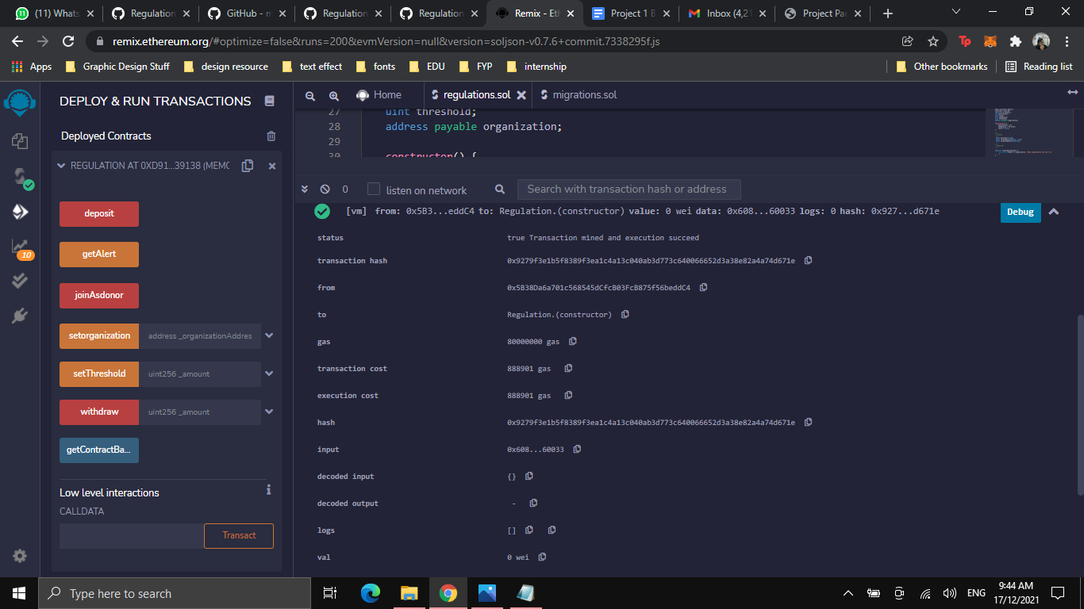

1. Set organization address

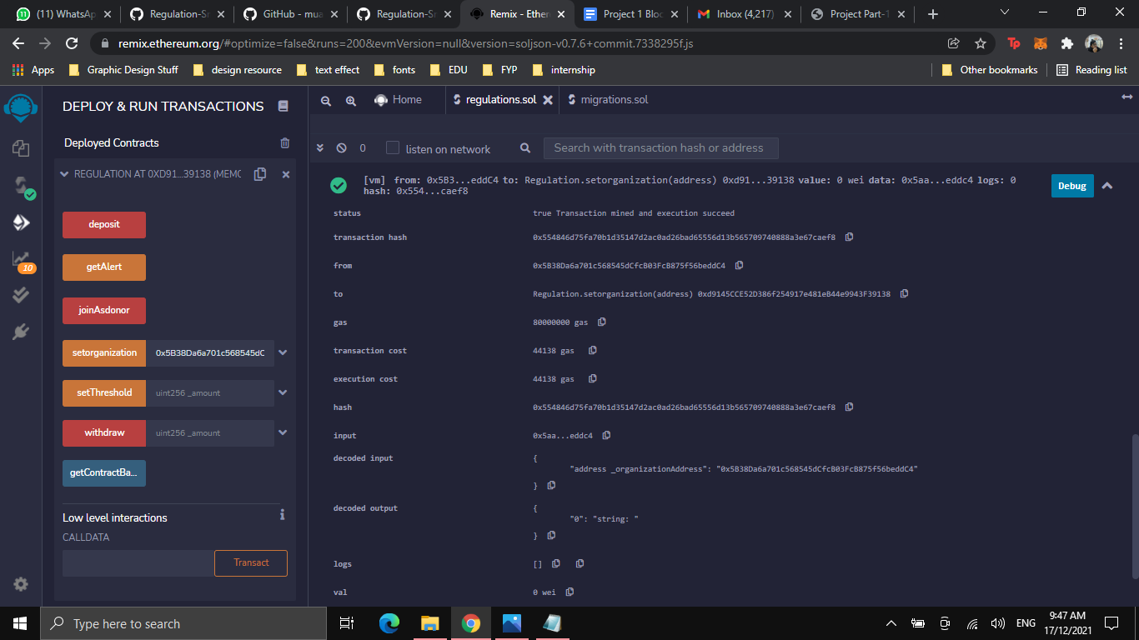

1. Organization has set 10 ether as threshold

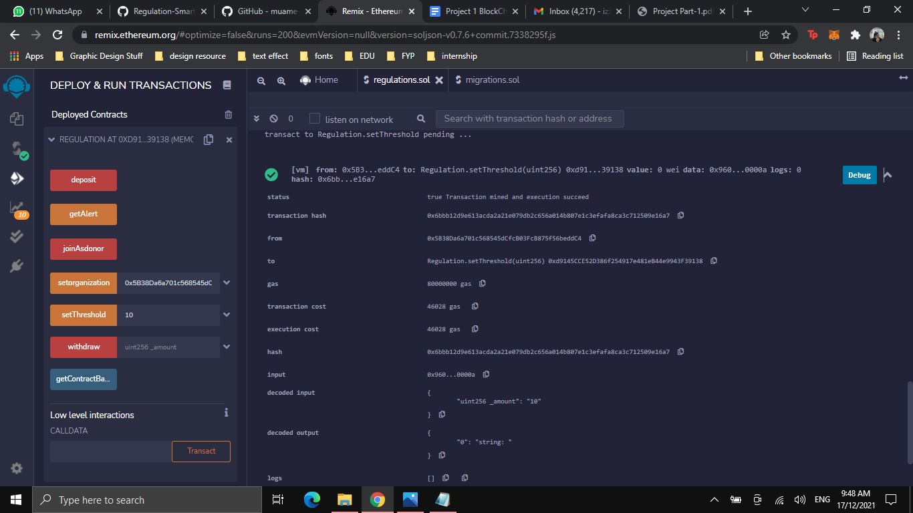

**Good Day Behaviour**

1. Join as donor for testing

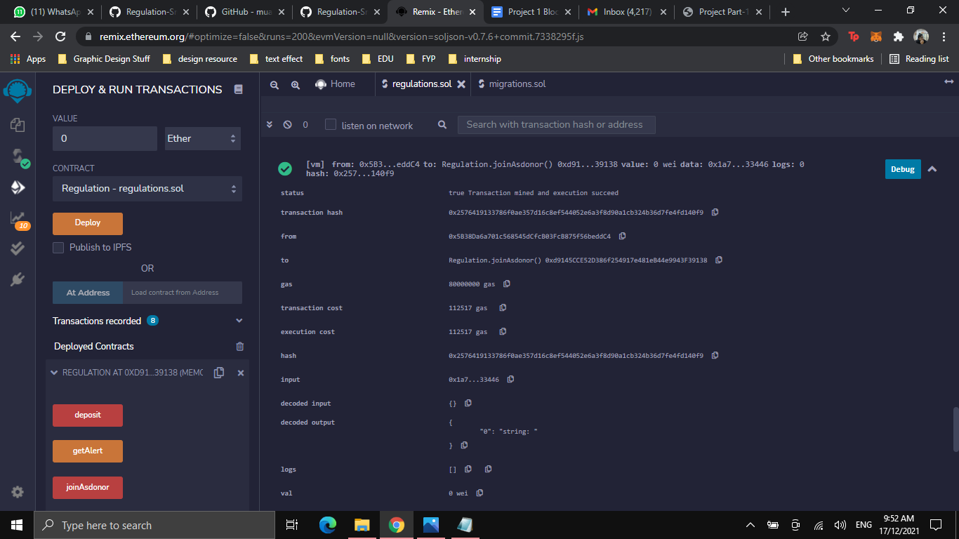

1. Deposit 5 Ether (not exceeding 10 Ether Threshold)

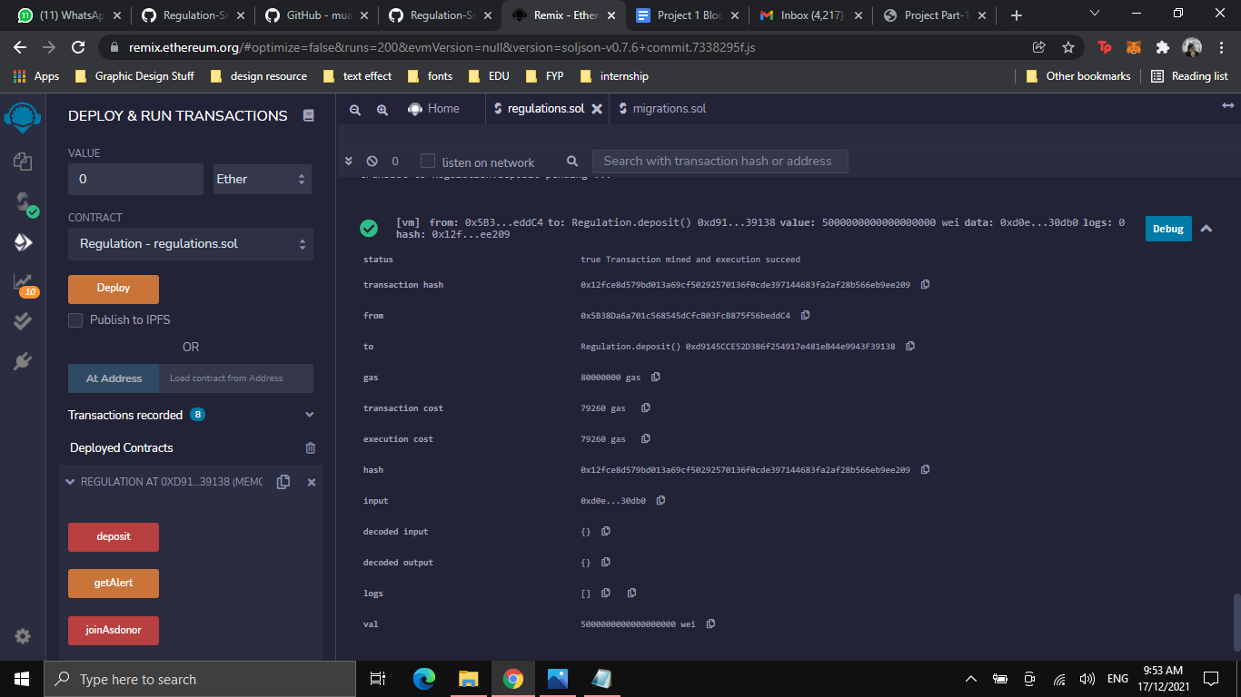

1. Get alert function (no suspicious transaction)

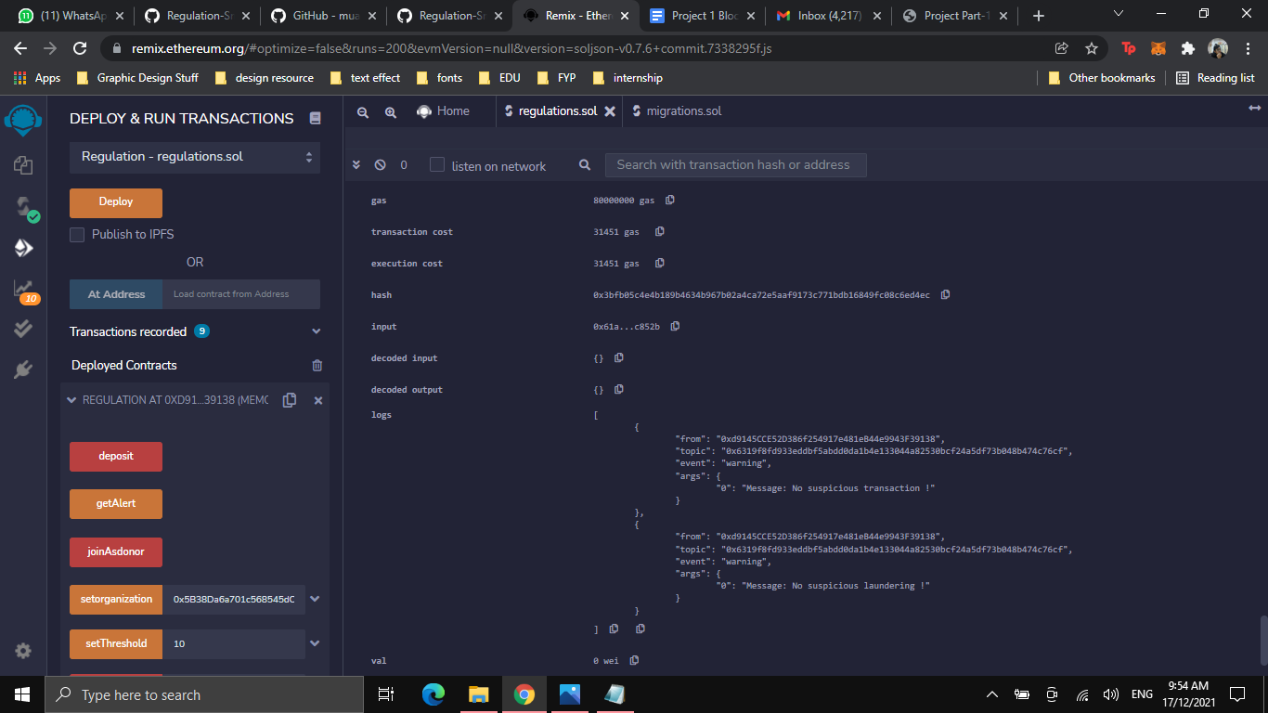

**Possible money laundering**

1. Deposit 20 ether (exceed threshold)

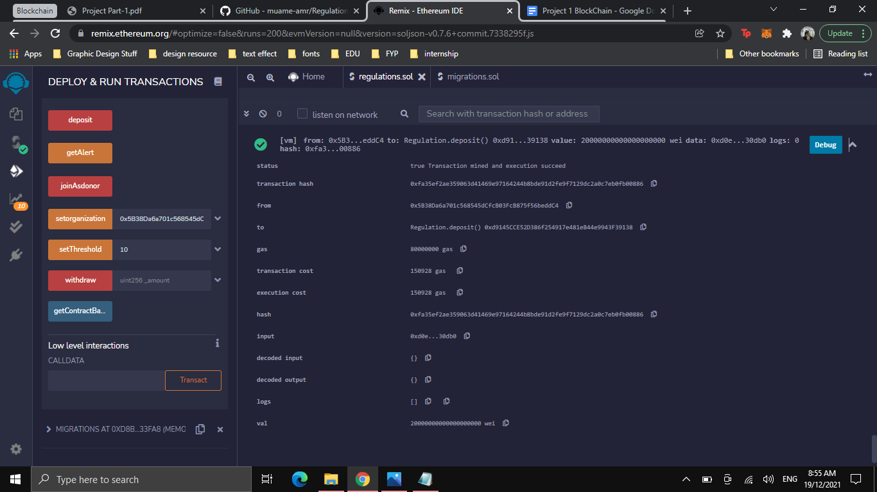

1. Withdraw 20 ether

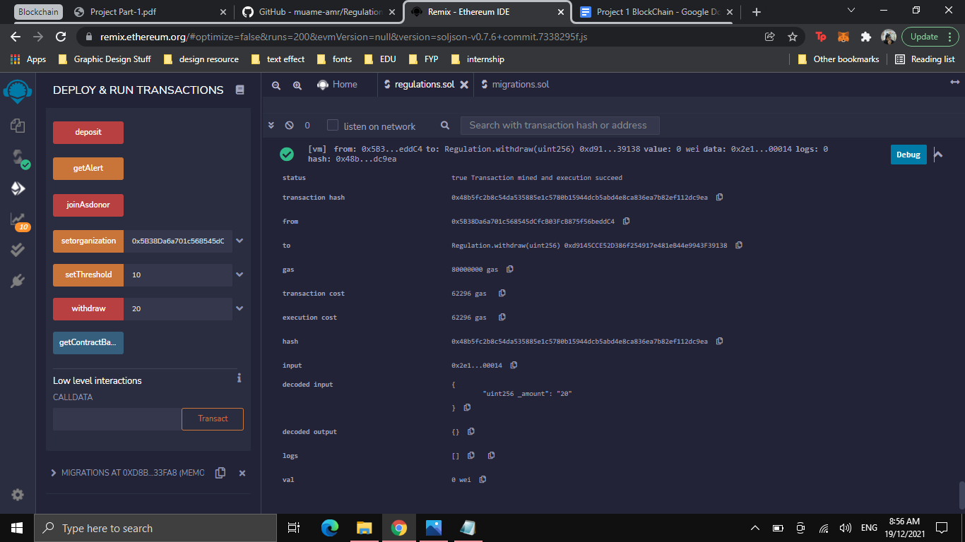

1. Alert message

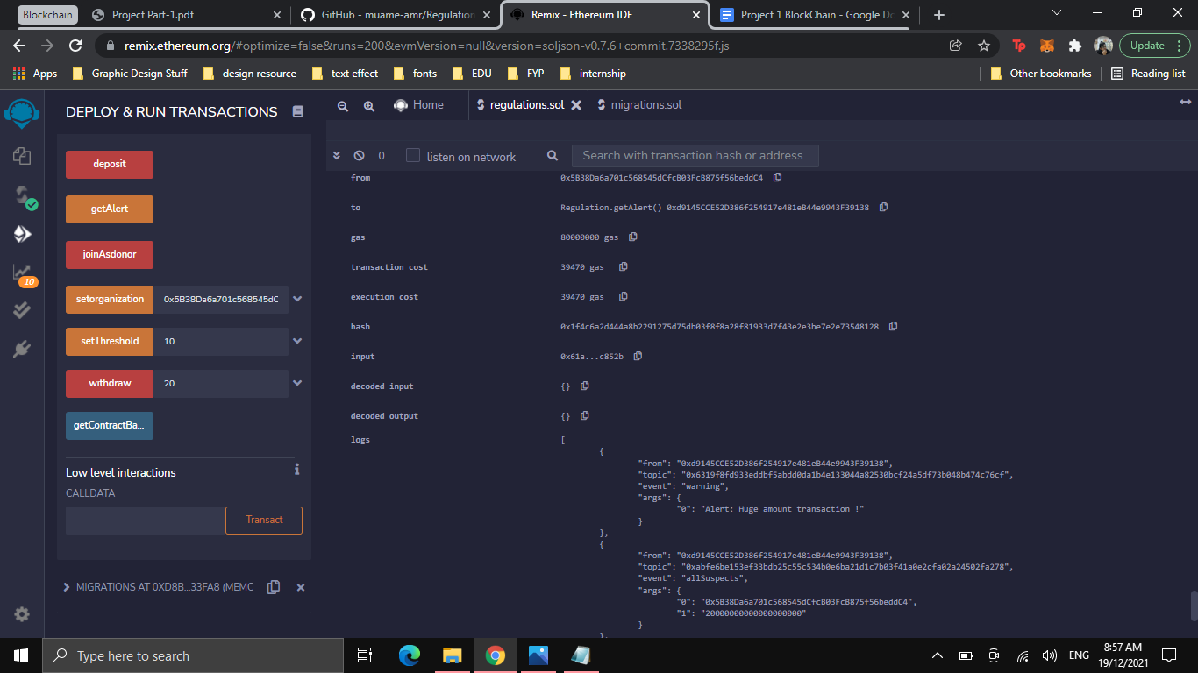

1. Get contract balance

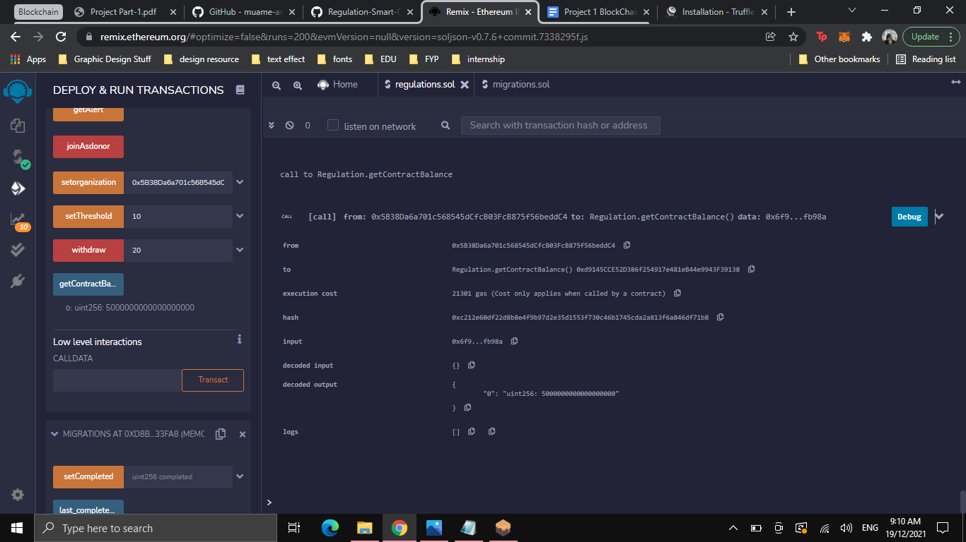

**Ganache output (Localhost Blockchain)**

